Morphometric Characteristics of Ice and Snow in the Arctic Basin: Aircraft Landing Observations from the Former Soviet Union, 1928-1989, Version 1

This data set contains sea ice and snow measurements collected during aircraft landings associated with the Soviet Union's historical Sever airborne and North Pole drifting station programs. The data set contains measurements of 23 parameters, including ice thickness and snow depth on the runway and surrounding area; ridge, hummock, and sastrugi dimensions and areal coverage; and snow density.

Summary

This data set contains sea ice and snow measurements collected during aircraft landings associated with the Soviet Union's historical Sever airborne and North Pole drifting station programs. The High-Latitude Airborne Annual Expeditions Sever (Sever means North) took place in 1928, 1937, 1941, 1948-1952, and 1954-1993 (Konstantinov and Grachev 2000). In Spring 1993, the last (45th) Sever expedition finished long-term activity in the Arctic. Snow and sea ice data were collected, along with meteorological and hydrological measurements (the latter are not part of this data set). Up to 202 landings were accomplished each year.
The data set contains measurements of 23 parameters, including ice thickness and snow depth on the landing runway and surrounding area; ridge, hummock, and sastrugi dimensions and areal coverage; and snow density. The sea ice thickness data are of particular importance, as ice thickness measurements for the Arctic Basin are scarce. These data are a subset of those used to create the atlas Morphometric Characteristics of Ice and Snow in the Arctic Basin, self-published by Ilya P. Romanov in 1993, and republished by Backbone Publishing Company in 1995. Romanov personally provided these data to the National Snow and Ice Data Center (NSIDC) in 1994. Note: NSIDC only holds data through 1989.

Background

In 1994, NSIDC received two data sets from Ilya Pavlovich Romanov, a scientist who spent his career with the Arctic and Antarctic Research Institute (AARI), St. Petersburg, Russia. One data set consists of files of gridded parameters that were used in the construction of the atlas Morphometric Characteristics of Ice and Snow in the Arctic Basin, self-published by Ilya P. Romanov in 1993, and republished in a revised version with accompanying data diskette and additional charts, as Atlas of Ice and Snow of the Arctic Basin and Siberian Shelf Seas, by Backbone Publishing Company in 1995. The second consists of files of raw (ungridded) data from aircraft landings on Arctic pack ice, beginning in 1928 and ending in 1989, with relatively few observations before the 1950s. NSIDC offers the raw observations, but not the gridded data, due to irregularities in the gridded data set. Unfortunately, Ilya Romanov died in 1995, before complete documentation on both data sets could be obtained. See Detailed Data Description for information on the contents of the new data set.
Romanov compiled and analyzed his database during his 45-year career with AARI. His field experience included 19 Sever expeditions and five North Pole drifting stations, as well as scientific leadership on the first voyage to the North Pole by icebreaker, in 1977 (Atlas of Ice and Snow of the Arctic Basin and Siberian Shelf Seas Editor's Preface, 1995). The AARI Sever and North Pole programs are described below. In 1959, Romanov initiated an extracurricular program of routine measurements of snow and ice that resulted in an extensive personal archive. This database grew to include previously collected snow and ice data as well (R. Colony, "Forward," Atlas of Ice and Snow of the Arctic Basin and Siberian Shelf Seas, 1995).
Data sources for the Romanov atlases are described as the AARI Sever expeditions (1940s to 1980s), the AARI North Pole drift stations (1937-1991), the US-USSR joint research Polar Experiment (POLEX) program (1972-1981), ice reconnaissance flight reports, and literature in the public domain ("Executive Summary," Atlas of Ice and Snow of the Arctic Basin and Siberian Shelf Seas, 1995). NSIDC has published the data from aircraft landings only and has not included extensive data from the North Pole program. The source of each year's observations is uncertain. The observations from 1928 may be connected with the rescue efforts of the airship Italia and the aircraft landings of Chukhnovsky and M.S. Babushkin during that period.
Romanov's atlases and observational data are a unique contribution to arctic science. Snow measurements were made in the spring and therefore represent annual snow accumulation prior to significant summer melt. Romanov's assessments of area, thickness and the spatial distribution of snow contribute information useful for evaluating arctic freshwater balance (Roger Barry, personal communication, 2003). Sea ice thickness data are valuable additions to the limited record provided by upward looking sonar. The Atlas of Ice and Snow of the Arctic Basin and Siberian Shelf Seas contains many additional parameters presented in climatological analyses, with background information on observational methods.

The Sever Program

The Sever (in English, "North") expeditions, more formally named the High-Latitude Airborne Expeditions, were an intensive data acquisition program conducted by AARI. Between 1948 and 1989, but primarily in the mid 1950s and again during 1973-1979, the Arctic Basin and shelf seas were annually sampled at up to 202 separate landing sites per season, where observers would stay for several days. The landings generally took place from mid March into early May, when there was enough light to operate, but before summer melt made safe landings impossible. The Sever program included the acquisition of oceanographic and meteorological data (notably, the program focused on the wintertime hydrography of the Kara, Laptev, East Siberian, and Chukchi Seas); however, Romanov's database includes only sea ice and snow data. For more information on Sever, see Environmental Working Group Joint U.S.-Russian Sea Ice Atlas, and Borodachev and Shilnikov, 2002 (in Russian only).

The North Pole Program

AARI's North Pole program consisted of drifting stations that generally were set up on multiyear ice floes. The first station began operations in 1937. Observations were interrupted during World War II and resumed in 1950. For 1954 through 1991, one to three stations were in operation each year, with varying 'lifetimes' before the ice floe broke up or drifted through Fram Strait. North Pole Drifting Station 1 lasted nine months and North Pole Drifting Station 22 lasted eight and a half years. Stations were set up by delivering personnel and equipment by air, and resupply was by air. They drifted until the floe was in danger of breaking up, at which time the men and equipment were retrieved. An average ice station lifetime was 31.5 months. The North Pole drifting station measurement program was extensive. This data set contains only a selection of sea ice and snow measurements that were acquired possibly during aircraft support for the North Pole program. A detailed history of the program, with a gallery of photographs, station meteorological data, and drift tracks, may be found in the Joint U.S.-Russian Arctic Meteorology and Climate Atlas (Arctic Climatology Project, 2000).

Detailed Data Description

These data, along with limited documentation, were obtained by NSIDC from I.P. Romanov in 1994. The atlas documentation (Romanov 1993, 1995) provided much of the information given here on data acquisition and parameter definition, although this information is still somewhat incomplete.
NSIDC received files that possibly are observations from Sever and North Pole station aircraft landing locations. These files apparently contain snow and ice observations from many but not all Sever stations and possibly from North Pole stations. Note that the Sever data and North Pole data are indistinguishable in the data files. It is likely that all data were acquired during aircraft landings using methods that were consistent regardless of which larger AARI program was being supported, but NSIDC cannot be sure of this information. NSIDC also received a different set of parameters as gridded data. These gridded data have some inconsistencies and are undocumented, and therefore are left out of this data set.
We assume that both the gridded data and the raw data received by NSIDC were used for the climatological atlases constructed by Romanov and published in 1993 and 1995. However, the parameters in this data set are only a subset, and not an exact match, to the parameters represented in the atlas climatologies. The 1993 atlas contains more than 100 hand-drawn climatological fields, with accompanying monograph. The 1995 second edition has been expanded and revised, with an additional 99 charts, new translation and introduction, and a data diskette with gridded data.

Parameters

Four ice thickness parameters (such as ice thickness of prevailing landing area), five ice morphology parameters (such as prevailing width of ridges), and 11 snow morphology and snow characteristic parameters (including area of sastrugi and density of snow), as well as floe and runway dimensions. The parameters measured are listed below..
- Ice thickness parameters are runway ice thickness, thickness of prevailing ice of landing area, thickness of ice pieces which form the hummock, and ice freeboard.
- Ice morphology parameters are prevailing height of hummocks in the ridges, prevailing width of ridges, maximum height of hummocks in the landing area height of old hummocks, and area of old hummocks.
- Snow morphology and snow characteristic parameters are snow height (depth) on runway, snow height (depth) on prevailing ice of landing area, height of sastrugi on the runway, area of sastrugi on the runway, height of sastrugi on prevailing ice of landing area, area of sastrugi on prevailing ice of landing area, depth, at mid-length, of snow dunes extending out from ridges, depth, at mid-length, of snow dunes extending out from ridges, snow height (depth) at hummocks on the windward side, snow height (depth) at hummocks on the lee side, and density of snow.
- Also included are floe and runway dimensions.

Format

The data files are in ASCII text. Each line in a data file contains the information specified in Table 1. The link from each parameter shows a scatterplot of that parameter's values.
Parameter Number | Missing Data Value | Units | Parameter Name | Variable name in DBF file
 | -1 |  | year | year
 | -1 |  | month | mm
 | -1 |  | day | dd
 | -1 | meters | length of runway | rw_xx
 | -1 | meters | width of runway | rw_yy
 | -1 | meters | length of floe | fl_xx
 | -1 | meters | width of floe | fl_yy
 | -1 | cm | runway ice thickness | rw_ih
 | -1 | cm | runway snow depth | rw_sh
 | -1 | cm | thickness of prevailing ice of landing area | la_ih
 | -1 | cm | snow depth on prevailing landing area ice | la_sh
 | -1 | cm | prevailing height of ridge hummocks | hr_hh
 | -1 | m | prevailing width of ridges | hr_ww
 | -1 | cm | maximum height of hummocks in the landing area | hr_mh
 | -1 | cm | thickness of ice pieces which form the hummock | hr_ph
 | -1 | cm | height of sastrugi on the runway | sg_hh
 | -1 | percent | area of sastrugi on runway | sg_ar
 | -1 | cm | height of sastrugi on prevailing ice on the landing area | sa_hh
 | -1 | percent | area of sastrugi on prevailing ice on the landing area | sa_ar
 | -1 | m | length of snow dunes extending out from ridges | sd_xx
 | -1 | cm | depth, at mid-length, of snow dunes extending out from ridges | sd_dd
 | -1 | cm | depth of snow on hummocks, windward side | sw_dd
 | -1 | cm | depth of snow on hummocks, lee side | sl_dd
 | -1 | cm | height of weathered hummocks | wh_hh
 | -1 | percent | area of weathered hummocks | wh_ar
 | -1 | cm | ice freeboard | ic_fb
 | -1 | .00 g/cm³ | density of snow | sn_den

Sample Data Record

1985 04 11 72.133 134.000 -1 -1 9999 9999 185 5 185 7 60 0 100 25 12 25 25 55 6 40 20 40 -1 -1 -1 -1.00
1985 04 11 72.033 132.733 -1 -1 9999 9999 130 10 130 15 120 0 150 50 18 25 28 55 11 60 40 70 -1 -1 -1 -1.00
Spatial and Temporal Coverage and Resolution
The maps in Figure 2 show the position of each landing site by decade. One data record exists for each location. The measurements were taken daily, sometimes at multiple locations, as early as January and as late as July; but usually late winter to summer, generally March through May. NSIDC holds data from 1928, 1937, 1941, 1948-1952, and 1954-1989. A single set of observations was taken at each landing site. The number of landing sites in any one year or month varied. In a given field season, the distance between landings averaged approximately 100 km.
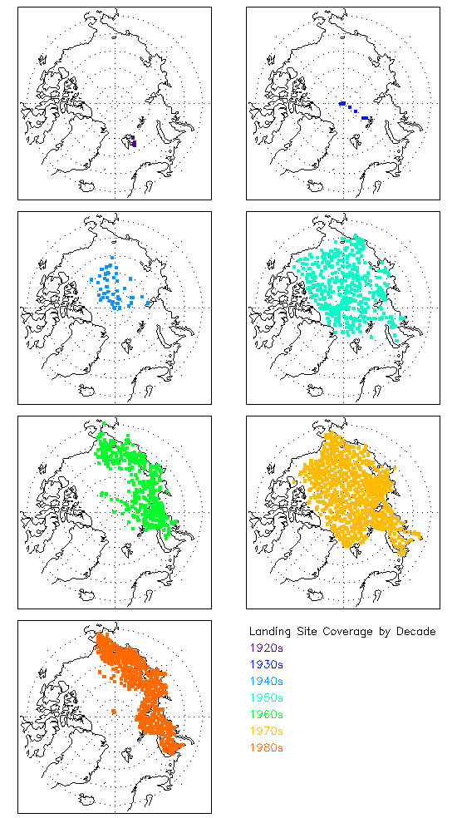
Figure 2. Landing Site Locations by Decade

Table 2 specifies the number of landing sites by decade and month.

Table 2. Landing Sites by Decade and Month
 | January | February | March | April | May | June | July
1920s |  |  |  |  |  | 4
1930s |  |  |  | 2 | 5
1940s |  |  |  | 21 | 24
1950s |  | 2 | 21 | 286 | 147 | 4 | 1
1960s | 3 | 13 | 107 | 282 | 290 | 46
1970s |  |  | 438 | 679 | 148
1980s |  | 3 | 380 | 526 | 339

Quality Assessment

Each parameter was examined for extreme values by plotting all values and visually scanning for obvious outliers. These values were then investigated to determine the nature of the error. Extreme values were rare and occurred as described below. The four outlying ice and snow parameters were replaced with the value for missing data. Some runway length, runway width, floe length, and floe width parameters have values of 9999 and -1. Values of -1 indicate missing data; the meaning of 9999 values is uncertain. Table 3 lists these extremes.

Table 3. Description of Data Value Outliers
Name of Field | Extreme Value | Date of Extreme Value (yyyymmdd) | Number of Extreme Values
Day | 0 | 196003__ | 1
Day | 0 | 196104__ | 13
Day | 0 | 198404__ | 23
Day | 0 | 198505__ | 1
Ice thickness runway | ? | 19740413 | 1
Prevailing height of hummocks in the ridges | ? | 19800515 | 1
Depth of snow on hummocks, windward side | ? | 19800413 | 1
Snow density | ? | 19810414 | 1

Data Acquisition and Processing

The information below (paraphrased from Romanov, 1995, except where noted) describes in general terms how data were acquired. In his supplemental observation program, Romanov enlisted the help of colleagues as ice observers (Romanov, preface to the 1993 atlas). Generally, observations were made following the instructions in the Handbook for Conducting Airborne Ice Reconnaissance.
Data Acquisition Methods
Before an ice landing, a characteristic site of ice- and snow-parameter variation was selected. Ice thickness and snow depth were evaluated at different locations on first-year, as well as multiyear ice. Hummocks were measured in 2-3 ridges characteristic of the region. The size of floes was measured both in flight and on the ice. In 1988-1989, ridges were evaluated at 5-m intervals at North Pole stations and at landing sites (Romanov, personal correspondence with R. Barry, R. Colony, and W. Weeks, 1 July 1992).

Ice Thickness

Age and partial concentration of ice were determined from low-flying aircraft. After landing, three to five measurements of thickness at 150-200-m intervals were made on the runway. If second-year and multiyear ice prevailed in the landing area, thickness was measured at 10-20 points on neighboring floes and at fresh fractures. The values were averaged and used both for analysis and for calibration of the visual airborne ice observation technique (Romanov 1995).

Hummocking and Ridging

Ridged ice concentration is defined as the percentage of the area covered by ridged and hummocked ice with respect to the total ice cover. It is the main parameter characterizing ice cover deformation. Observations of ridged ice concentration were systematically carried out from aircraft by counting the number of iced ridges per kilometer and by visual estimates in accordance with the Handbook for Conducting Airborne Ice Reconnaissance (1981 and earlier issues). Additionally, a program of direct measurements of ice ridge concentrations, including their heights and widths, was conducted every March-April from 1972 to 1982. During this program, aircraft landed on the ice cover of every 100x100-km cell of the Arctic Basin and adjacent seas. The heights and widths of several typical ridges were measured, with 5-10 measurements on each ridge. In addition, the thickness, length, and width of ice pieces forming the ridge were measured (Romanov 1995).

Snow on Sea Ice

Representative areas for measuring snow parameters were chosen from the air. After landing, snow depth was measured at 10-20 random points and on characteristic forms of ice surface terrain (including level ice, frozen melt ponds, and ridges). Snow depth on level first-year and, whenever possible, on multiyear ice was measured at 3-5 points on the runway. For snow cover more than 10 cm deep, at least 10 measurements were made over the entire ice floe, as well as on adjacent floes. Snow depth in 2-3 snow-covered ridges was measured on both windward and lee sides using a measuring pole at 10-20 points. The area covered by sastrugi was estimated from the air. After landing, the airborne observation data were checked, and other measurements made. Lengths and depths (at their mid-lengths) of snow dunes stretching from ice ridges at various angles were measured at 3-5 sites during every landing (Romanov 1995).
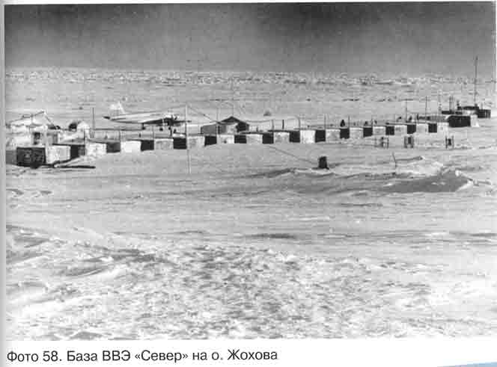Figure 3. High-latitude expedition Sever base on Zhokhov Island (photo taken by Sergey Kessel, used with permission).

References and Related Publications

More information on Ilya P. Romonov and on historical Russian ocean, atmosphere and ice observing programs can be found in the publications below. The 1993 and 1995 Romanov references contain additional descriptive information and analyses, of which this data set forms only a small part.
Arctic Climatology Project. 2000. Environmental Working Group Joint U.S.-Russian Sea Ice Atlas. Edited by F. Tanis and V. Smolyanitsky. Ann Arbor, MI: Environmental Research Institute of Michigan in association with the National Snow and Ice Data Center. CD-ROM.
Arctic Climatology Project. 2000. Environmental Working Group Arctic Meteorology and Climate Atlas. Edited by F. Fetterer and V. Radionov. Boulder, CO: National Snow and Ice Data Center. CD-ROM.
Borodachev, V.E. and V. I. Shilnikov. 2002. Istoriya Ledovoi Aviatsionnoi Razvedki v Arktike i na Zamerzayushchikh Moryakh Rossii (1914-1993) (The History of Aerial Ice Reconnaissance in the Arctic and Ice-covered Seas of Russia, 1914-1993). Gidrometeoizdat Publishing House, St. Petersburg, Russia. 441 pp. ISBN 5-286-01448-8.
Colony, R., V. Radionov, and F. J. Tanis. 1998. Measurements of precipitation and snow pack at Russian North Pole drifting stations. Polar Record 34(188): 3-14.
Konstantinov, Yu. B., K. I. Grachev. 2000. High-latitude Airborne Expeditions Sever (1937, 1941 – 1993). Gidrometeoizdat Publishing House, St. Petersburg, Russia, 176 pp.
Romanov, I.P. 1979. Sizes of Ice Fields. Trans. POLEX-Sever-76. Gidrometeoizdat Publishing House, St. Petersburg, Russia. pp. 11-115.
Romanov, I. P. 1992. Ledyanoy pokrov Arkticheskogo basseyna (Ice cover of the Arctic Basin). Self-published. St. Petersburg, Russia, 211 pp. (in Russian)
Romanov, I.P. 1993. Morphometric Characteristics of Ice and Snow in the Arctic Basin. First edition. Self-published. St. Petersburg, Russia.
Romanov, I.P. 1995. Atlas of Ice and Snow of the Arctic Basin and Siberian Shelf Seas. Dr. Alfred Tunik, translator and editor. Second edition of atlas and monograph. Revised and expanded. ISBN 0-9644311-3-0. Backbone Publishing Company.
Rukovodstvo po proizvodstvu ledovoy aviarazvedki (Handbook for conducting airborne ice reconnaissance). 1981. Gidrometeoizdat Publishing House, St. Petersburg, Russia. 240 pp.
Warren, S. G., I. G. Rigor, N. Untersteiner, V. F. Radionov, N. N. Bryazgin, Y. I. Aleksandrov, and R. Colony. 1999. Snow depth on Arctic sea ice. Journal of Climate 12: 1814-1829. doi: https://doi.org/10.1175/1520-0442(1999)012%3C1814:SDOASI%3E2.0.CO;2.

Contacts and Acknowledgments

Acknowledgments:

These data were provided by Ilya Pavlovich Romanov (1927-1995). Valuable information concerning the Romanov data and the Sever and North Pole programs was supplied by Prof. Roger Colony, International Arctic Research Center, University of Alaska, Fairbanks; Dr. Vladimir Radionov, Head of the Department of Meteorology, AARI; and Prof. Roger Barry, Director, NSIDC. All three reviewed this documentation. Dr. Colony was instrumental in the publication of the first English version of Romanov's atlas, Morphometric Characteristics of Ice and Snow in the Arctic Basin. We acknowledge as well the contribution of Ilya Romanov's son, Andrey Romanov, who completed the delivery of data to NSIDC after his father's death.
Preparation of the data set at NSIDC was supported by funding from NOAA's National Environmental Satellite, Data, and Information Service (NESDIS) and the National Geophysical Data Center (NGDC).

Document Information

Document Authors

This documentation was written by Keri Webster, Alexander Machado, and Florence Fetterer based on correspondence between Ilya Romanov and NSIDC dated 1 July 1992, and on correspondence between Romonov's son Andrey Romanov and NSIDC dated 10 September 1995. We drew additional information from the Romanov atlases (1993, 1995) and from personal communications with R. Colony, R. Barry, and V. Radionov (see Acknowledgments).

Document Creation Date
20 February 2004

Document Revision Date
30 December 2005 (F. Fetterer added information to the Acknowledgments section)

