INTERNATIONAL HYDROGRAPHIC ORGANIZATION



**ICE Product Specification - Draft**

**Edition 0.0.1, May 2012**

**Special Publication S-107**

Published by the

International Hydrographic Bureau

**MONACO**

S-107

Page intentionally left blank

**Record of Document Maintenance**

|  |  |  |  |
| --- | --- | --- | --- |
| **Date** | **Description** | **Authority** | **Version** |
|  |  |  |  |
|  |  |  |  |
|  |  |  |  |
|  |  |  |  |
|  |  |  |  |
|  |  |  |  |
|  |  |  |  |

|  |
| --- |
| © Copyright International Hydrographic Organization 2011 |
| This work is copyright. Apart from any use permitted in accordance with the [Berne Convention for the Protection of Literary and Artistic Works](http://www.wipo.int/treaties/en/ip/berne/trtdocs_wo001.html) (1886), and except in the circumstances described below, no part may be translated, reproduced by any process, adapted, communicated or commercially exploited without prior written permission from the International Hydrographic Bureau (IHB). Copyright in some of the material in this publication may be owned by another party and permission for the translation and/or reproduction of that material must be obtained from the owner. |
| This document or partial material from this document may be translated, reproduced or distributed for general information, on no more than a cost recovery basis. Copies may not be sold or distributed for profit or gain without prior written agreement of the IHB and any other copyright holders. |
| In the event that this document or partial material from this document is reproduced, translated or distributed under the terms described above, the following statements are to be included: |
| *“Material from IHO publication [reference to extract: Title, Edition] is reproduced with the permission of the International Hydrographic Bureau (IHB) (Permission No ……./…) acting for the International Hydrographic Organization (IHO), which does not accept responsibility for the correctness of the material as reproduced: in case of doubt, the IHO’s authentic text shall prevail. The incorporation of material sourced from IHO shall not be construed as constituting an endorsement by IHO of this product.”* |
| *“This [document/publication] is a translation of IHO [document/publication] [name]. The IHO has not checked this translation and therefore takes no responsibility for its accuracy. In case of doubt the source version of [name] in [language] should be consulted.”*  The IHO Logo or other identifiers shall not be used in any derived product without prior written permission from the IHB. |

CONTENTS

1 Introduction 1

2 Data Product Specification Metadata 2

3 Overview 2

3.1 InformalDescription 2

4 References 2

5 Terms, definitions and abbreviations 3

5.1 Terms and Definitions 3

6 Abbreviations 4

7 Specification Scope 5

8 ICE Data Product Identification 5

9 Data Content and Structure 5

10 Application Schema 6

10.1 Feature Catalogue 7

10.2 Reference Systems 7

11 Geometric representation 9

12 Quality 9

13 Maintenance 9

14 Data Encoding 9

15 Data Product Delivery Information 10

16 Exchange Set 10

16.1 Support Files 10

16.2 Support File Naming 11

17 Metadata 11

17.1 Dataset Metadata 12

17.1.1 Information about the documented metadata (if provided as a separate resource) 12

17.2 Exchange Set Metadata 13

17.2.1 Exchange Catalogue File Metadata 14

18 Portrayal 15

Appendix 1 - *Ice_Objects_Catalogue_V4-0.pdf*

Appendix 2 - *ICE UML All Objects and Simple Types.png*

Page intentionally left blank

# Introduction

This document has been produced by the …. in response to a requirement to produce a data product that can be used as Marine Information Overlay (MIO) within Electronic Chart Display and Information Systems. It is based on the IHO S-100 framework specification and the ISO 19100 series of standards. It is a vector product specification that is primarily intended for encoding the extent and nature of Sea Ice for navigational purposes

.

# Data Product Specification Metadata

This section provides metadata about the creation of this data product specification.

**Title:** IHO S-107 Sea Ice – Data Product Specification

**S-100 Version:** 1.0.0 (January 2010)

**Ice Version:** 0.0.1 Draft

**Date:** April 2012

**Classification:** Unclassified

**Contact:** International Hydrographic Bureau

4 Quai Antoine 1er

B.P. 445

MC 98011 MONACO CEDEX

Telephone: + 377 93 10 81 40

Fax: +377 93 10 81 40

URL: [www.iho-ohi.net](http://www.iho-ohi.net)

**Document Identifier:** IHO Publication S-107

**Maintenance**: The document is maintained by the … . New editions will be published as determined by the … , and will be made available for download from the … web site.

# Overview

## InformalDescription

A number of northern nations, particularly, Canada, the United States, Germany and those bordering on the Baltic Sea, maintain Ice Services, and issue ice charts on a regular basis during winter months. These ice charts are used on ships as an aid to navigation in ice infested waters, and as ECDIS becomes more widely available on ships navigating these northern waters, it will be important to provide ice data in a form that can be used in those systems.

# References

The following normative documents contain provisions that, through reference in this text, constitute provisions of this document.

IHO S-100 IHO Universal Hydrographic Data Model, Version 1.0.0

ETSI Ice Objects Catalogue, Version 4

IHO GEOSPATIAL STANDARD FOR MARINE PROTECTED AREAS, Draft 0.0.2 – February 2012

# Terms, definitions and abbreviations

## Terms and Definitions

**application**

manipulation and processing of data in support of user requirements (ISO 19101)

**application schema**

**conceptual schema** for data required by one or more **applications (**ISO 19101]

**conceptual model**

modelthat defines concepts of a **universe of discourse** (ISO 19101]

**conceptual schema**

formal description of a **conceptual model** (ISO 19101]

**coverage**

**feature** that acts as a function to return values from its range for any direct position within its spatial, temporal or spatiotemporal **domain** (ISO 19123]

EXAMPLE Raster image, polygon overlay, digital elevation matrix.

**data product**

**dataset** or **dataset series** that conforms to a **data product specification**

**data product specification**

detailed description of a **dataset** or **dataset series** together with additional information that will enable it to be created, supplied to and used by another party

NOTE A data product specification provides a description of the universe of discourse and a specification for mapping the universe of discourse to a dataset. It may be used for production, sales, end-use or other purpose.

**dataset**

identifiable collection of data (ISO 19115]

NOTE A dataset may be a smaller grouping of data which, though limited by some constraint such as spatial extent or feature type, is located physically within a larger dataset. Theoretically, a dataset may be as small as a single feature or feature attribute contained within a larger dataset. A hardcopy map or chart may be considered a dataset.

**dataset series**

collection of **datasets** sharing the same product specification (ISO 19115]

**domain**

well-defined set (ISO/TS 19103]

NOTE Well-defined means that the definition is both necessary and sufficient, as everything that satisfies the definition is in the set and everything that does not satisfy the definition is necessarily outside the set.

**feature**

abstraction of real world phenomena (ISO 19101]

NOTE A feature may occur as a type or an instance. Feature type or feature instance shall be used when only one is meant.

**feature association**

relationship that links instances of one **feature** type with instances of the same or a different

**feature** type (ISO19110]

NOTE 1 A feature association may occur as a type or an instance. Feature association type or feature association instance is used when only one is meant.

NOTE 2 Feature associations include aggregation of features.

**feature attribute**

characteristic of a **feature** (ISO 19101]

NOTE 1 A feature attribute may occur as a type or an instance. Feature attribute type or feature attribute instance is used when only one is meant.

NOTE 2 A feature attribute type has a name, a data type and a domain associated to it. A feature attribute for a feature instance has an attribute value taken from the domain.

**geographic data**

data with implicit or explicit reference to a location relative to the Earth (ISO 19109]

NOTE Geographic information is also used as a term for information concerning phenomena implicitly or explicitly associated with a location relative to the Earth.

**metadata**

data about data (ISO 19115]

**model**

abstraction of some aspects of reality (ISO 19109]

**portrayal**

presentation of information to humans (ISO 19117]

**quality**

totality of characteristics of a product that bear on its ability to satisfy stated and implied needs (ISO 19101]

# Abbreviations

ASCII American Standard Code for Information Interchange  
ENC Electronic Navigational Chart  
GML Geography Markup Language  
IHO International Hydrographic Organization  
IOC International Oceanographic Commission  
ISO International Organization for Standardization  
MIO Marine Information Overlay  
NPIO Nautical Publication Information Overlay  
UML Unified Modelling Language  
URI Uniformed Resource Identifier  
URL Uniform Resource Locator  
WMS Web Map Service  
WFS Web Feature Service  
www World Wide Web  
WGS World Geodetic System  
XML Extensible Markup Language  
XSLT eXtensible Stylesheet Language Transformations

# Specification Scope

**Scope ID:** Ice datasets.

**Hierarchical level:** 005 – (from 19115 - MD_ScopeCode)

**Hierarchical level name:** dataset

**Level description:** information applies to the dataset

**Extent:** EX_GeographicExtent - Global coverage of maritime areas.  
EX_TemporalExtent and EX_VerticalExtent are not defined for this product specification.

# ICE Data Product Identification

The following information is intended to describe the ICE data product.

**Title**: ICE

**Abstract**: Data product describing Ice Areas that are of significance to mariner operating in ice areas.

**Purpose**: A data product for encoding and transferring Ice Information for use within electronic navigational systems such as ECDIS.

**Topic** **category**: environment

**Content**: A conformant data set contains features defined by the Ice Objects Catalogue and described in the application schema as shown in Figure …

**Description**: An S-100 compliant rendering of Ice information.

**Spatial** **Extent**: East Bounding Longitude: 180  
West Bounding Longitude: -180  
North Bounding Latitude: 90  
South Bounding Latitude: -90

**Specific Purpose**: Ice datasets provide information regarding the ice covered areas for navigational purposes.

**Spatial** **representation** **type**: vector

# Data Content and Structure

The ICE product is based on the S-100 General Feature Model (GFM). A General Feature Model is a metamodel of feature types. A feature may have properties that may be operations, attributes or associations. Any feature may have a number of attributes, some of which may be geometric and spatial. A feature is not defined in terms of a single geometry, but rather as a conceptually meaningful object within a particular domain of discourse, one or more of whose properties may be geometric. The 'Feature' is the fundamental unit of geospatial information, so the Feature Model is the fundamental meta-model used for developing an Application Schema.

This section contains the ICE Application Schema expressed in UML and an associated Feature Catalogue. The Feature Catalogue included at Appendix 1 (Ice Objects Catalogue, Version 4) provides a full description of each feature type including its attributes, attribute values and relationships in the data product.

ICE is encoded as vector entities which are derived from geometry element GM_Object as per S-100 Version 1.0.0 Figure 7.3.

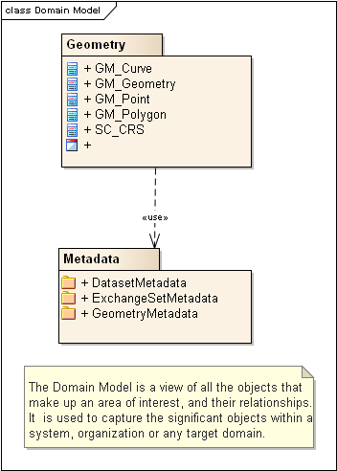

Figure 1 – Domain Model Overview

# Application Schema

The UML model shown in Figure 2 below illustrates a simplified version of the ICE application schema. It includes a general description of elements used to construct the application schema, and the relationships between them. These Elements include feature types, simple attributes, complex attributes, aggregations and associations. In this case only 3 representative objects are used, one for each in ICE available geometric primitive type (polygon, linestring and point).

A feature is an abstraction of real world phenomena. GF_FeatureType is a metaclass that is instantiated as classes that represent individual feature types. A certain feature type is the class used for all instances of that feature type. The instance of a class that represents an individual feature type is called feature instances. In object-oriented modeling, feature types are equivalent to classes and feature instances are equivalent to objects.

An information type is an identifiable object that can be associated with features in order to carry information pertaining to the associated features. S100_GF_InformationType is the class intended for information types within S-100. A primary object carrying a Chart Note for example, may contain text in English and an associated supplementary information object may be used to carry the same text in another language.

Simple attributes can be enumerations, code lists or simple types (e.g. integer or character string).

Complex attributes are properties of a feature which can be divided into multiple sub attributes and are used where objects have properties that better fit a hierarchical structure. They provide a better construct for encoding list attributes on objects such as light sectors.

An association is a relationship that links instances of one feature or information type with instances of the same or different feature and information types. Each relationship has a name and two roles thus giving a more detailed representation of the real world relationships within the dataset. The ICE application schema is presented as a UML model in Figure 3.

## Feature Catalogue

The Feature Catalogue describes the feature types, attributes, attribute values, associations and roles which may be used in an ICE. The Feature Catalogue is available from the IHO website as an XML document which conforms to the S-100 XML Feature Catalogue Schema. The feature catalogue of ICE is available in Appendix 1 (Ice Objects Catalogue, Version 4).

## Reference Systems

The CRS used for this product specification is World Geodetic System (WGS) 84 which is defined by the the European Petroleum Survey Group (EPSG) code 4326.

Spatial data are expressed as latitude (φ) and longitude (λ) geographic coordinates. Longitude values are stored as a negative number to represent a position west of the Prime Meridian (0°). Latitude values are stored as a negative number to represent a position south of the Equator (0°). Coordinates are expressed as real value, degree / degree decimal format. Datasets conforming to this product specification are not projected.

**Spatial reference system****:** Horizontal coordinate reference system: WGS 84

**Projection:** None

**Vertical coordinate reference system:** WGS 84

**Temporal reference system:** Gregorian calendar

**Coordinate reference system registry:** [EPSG Geodetic Parameter Registry](http://www.epsg-registry.org/)

**Date type (according to ISO 19115):** 002 - publication

**Responsible party:** International Organisation of Oil and Gas Producers (OGP)

**URL:** <http://www.ogp.org.uk/>

**Coordinate reference system identifier (CRSID):** 4326 (or 4617 for NAD 83)

**Code space: OGP** – OGP

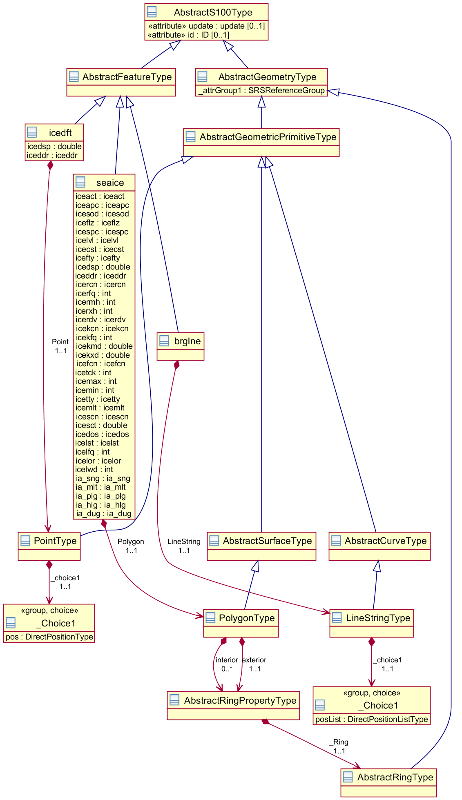

ICE

App

MetaData

Figure 2 – ICE Application Schema (Simplified with 3 representative feature types).

# Geometric representation

Geometric representation is the digital description of the spatial component of an object as described in S-100 and ISO 19107. This product specification uses three types of geometries: GM_Point, GM_Curve, and GM_Polygon (GM_Surface).

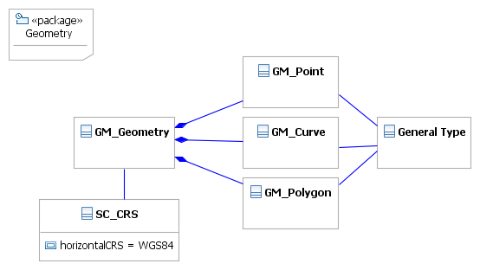

Figure 3 – Geometric Primitives

# Quality

To be done.

# Maintenance

To be done.

# Data Encoding

The principal encoding will be the Open Geospatial Consortium (OGC), Geography Markup Language (GML) format. GML is an XML grammar designed to express geographical features. It serves as a modeling language for geographic systems as well as an open interchange format for geographic transactions.

# Data Product Delivery Information

This data product specification defines GML as the primary format in which ICE data product are to be delivered. Information concerning the delivery medium should also be included. If a data product is to be delivered in different formats, then the appropriate information for each shall be given.

The delivery format information should include the following items (from ISO/DIS 19131:2005 with some changes of obligation): format name, version, language, character set.

Delivery format information may also include (from ISO/DIS 19131:2005): specification, file structure.

Delivery medium information may include (from ISO/DIS 19131:2005): units of delivery.

|  |  |  |
| --- | --- | --- |
| **Name** | **ISO 19131 Elements** | **Value** |
| Format name | DPS_DeliveryInformation.deliveryFormat > DPS_DeliveryFormat.formatName | GML |
| Version | DPS_DeliveryInformation.deliveryFormat > DPS_DeliveryFormat.version | 3.2.1 |
| Specification description | DPS_DeliveryInformation.deliveryFormat > DPS_DeliveryFormat.specification | See * below |
| Language | DPS_DeliveryInformation.deliveryFormat > DPS_DeliveryFormat.language | English English |
| Character set | DPS_DeliveryInformation.deliveryFormat > DPS_DeliveryFormat.characterSet > MD_CharacterSetCode | 004 – utf8 |

* GML is an XML encoding for the transport and storage of geographic information, including both the geometry and the properties of geographic features, between distributed systems. The XML Schema for the GML application schema is provided in a single schema document *S-107 XML Shema.xsd*. (http.// …..) Feature instance shall validate against *S-107 XML Shema.xsd* and conform to all other requirements specified in this data product specification including all constraints not captured in the XML Schema document.

# Exchange Set

An exchange set will consist of one or more ICE datasets. An exchange set may also include one or more support files containing supplementary information encoded in separate files. These are linked to the ICE dataset features, using the attributes described below. Each exchange set will include a single (XML) catalogue file containing discovery metadata for each ICE data as well all support files that will be included in the exchange set. ICE attributes that reference external support files are listed below.

textualDescription (TXTDSC) (see complex attribute textualDescription)

nationalTextualDescription - NTXTDS (not included - is the a need to include national textual description?)

pictorialRepresentation (PICREP) (see abstract feature type)

## Support Files

Support files contain ancillary textual or graphic information in separate (linked) files. Textual information may be encoded in an unstructured (TXT) or structured (XML / HTML 4) format.

Picture files must be encoded in one of the following W3C graphics formats;

Portable Network Graphics (PNG) [Edition 2.0] must be used for picture (raster) files and;

Scalable Vector Graphics (SVG) [Edition 1.1] must be used for vector diagrams.

PNG is an extensible file format designed for lossless, portable storage of raster images. It provides a patent-free replacement for the GIF format and also replicates many common uses of TIFF. The PNG edition 2 format has been adopted as an ISO standard, (ISO/IEC 15948:2003). SVG is a language for describing two-dimensional graphics in XML [XML10]. SVG allows for three types of graphic objects: vector graphic shapes (e.g., paths consisting of straight lines and curves), images and text.

## Support File Naming

All support files will have unique world-wide file identifiers. The file identifier of support information should not be used to describe the physical content of the file. The support file metadata that accompanies the file will inform the user of the name and purpose of the file (i.e. new, replacement and deletion).

In this encoding the support files are named according to the specifications given below:

CCXXXXXXXX.E00

The main part forms an identifier where:

* the first two characters identify the issuing agency.
* the third to tenth characters can be used in any way by the producer to provide the unique file name. The following characters are allowed in the dataset name, A to Z, 0 to 9 and the special character _ (underscore).
* .E00 – support file extension.

# Metadata

The ICE metadata description is based on the S-100 metadata document section, which is a profile of the ISO 19115 standard. These documents provide a structure for describing digital geographic data and define metadata elements, a common set of metadata terminology, definitions and extension procedures.

Two main types of metadata are described in this product specification; dataset metadata and exchange set metadata.

DatasetMetadata

+ DataSetDiscoveryMetadata

+ SupportFileDiscoveryMetadata

GeometryMetadata

+ ExchangeCatalogueFileMetadata

ExchangeSetMetadata

## Dataset Metadata

Dataset metadata is intended to describe information about a dataset or data resource. It facilitates the management and exploitation of data and is an important requirement for understanding the characteristics of a dataset (and or data resource). Whereas dataset metadata is usually fairly comprehensive, there is also a requirement for a constrained subset of metadata elements that are usually required for discovery purposes. Discovery metadata are often used for building web catalogues, and can help users to determine whether a product or service is fit for purpose and how/where they can be accessed.

### Information about the documented metadata (if provided as a separate resource)

|  |  |  |  |  |
| --- | --- | --- | --- | --- |
| **Name** | **Cardinality** | **Value** | **Type** | **Remarks** |
| DataSetDiscoveryMetadata |  |  |  |  |
| metadataFileIdentifier | 1 |  | CharacterString |  |
| metadataPointOfContact | 1 |  | CI_ResponsibleParty | Contact information for the vessel or authority |
| metadataDateStamp | 1 |  | Date | When the dataset was created |
| metadataLanguage | 1 | English, | CharacterString | All data sets conforming to this PS must use English |
| fileName | 1 |  | CharacterString | Dataset file name |
| filePath | 1 |  | CharacterString | Full path from the exchange set root directory |
| description | 1 |  | CharacterString |  |
|  |  |  |  | NATIONAL LANGUAGE enabled |
| dataProtection | 1 | {1} to {2} | CharacterString | 1. Unencrypted  2. Unencrypted |
| purpose |  | {1} to {2} | CharacterString | 1. New dataset  2. Update |
|  |  |  |  |  |
|  |  |  |  |  |
|  |  |  |  |  |
| specificUsage |  | {1} to {2} | Integer | 1, Notices of Arrival: A dataset containing a new or updated notice of arrival as required by local or national regulations |
|  |  |  |  | 2. A new or updated request for making pilotage arrangements |
| editionNumber | 1 | {1} | Integer | The dataset edition. Required for s100 but not applicable to ICE, therefore it is set to 1 for all datasets. |
| updateNumber | 1 |  | CharacterString | Update number 0 is assigned to a new request or notice. Subsequent updates or supplements are assigned numbers 1, 2, 3… |
| issueDate | 1 |  | Date | Date on which the dataset was generated. |
| productSpecification | 1 | ICE version 1.0.0 | S100_ProductSpecification | This must be encoded as ICE |
| producingAgency | 1 |  | CI_ResponsibleParty | Party responsible for generating the dataset. |
| horizontalDatum | 1 | WGS84 | CharacterString | The datum for latitude/longitude. EPSG:4326 |
| verticalDatum | 1 | {1} to {30} | Integer | Mean low water springs  (29 other values) |
|  |  |  |  |  |
| soundingDatum | 1 | {1} to {30} | Integer | Mean low water springs  (29 other values) |
|  |  |  |  |  |
| dataType | 1 | other | S-100_DataFormat | GML. Or other possible S-100 defined formats. |
| otherDataTypeDescription | 0..1 |  | CharacterString |  |
| boundingBox | 0..1 |  | EX_GeographicBoundingBox | Either boundingBox or geographicDescription must be given. |
| boundingPolygon | 0..* |  | EX_BoundingPolygon |  |
| geographicDescription | 0..1 | Norway | EX_GeographicDescription | Descriotion of the location for notices or requests, in the form of the country of the national authority. Either boundingBox or geographicDescription must be given. |
| comment | 0..1 |  | CharacterString | Any additional Information |
| cyclicRedundancyCheck | 1 | NonNegativeInteger |  | Check value for the dataset |
| layerId | 1 | {1} | integer | Identifies the relationship to other S100 information on a graphical display.  1.Scale Independent  2. Scale Independent |
|  |  |  |  |  |

Note: Types with CI_, EX_, and MD_ prefixes are from packages defined in ISO 19115 and adapted by S-100. Types with S100_ prefix are from packages defined in S-100.

## Exchange Set Metadata

Frequently datasets are packaged and distributed as composite exchange sets by third party vendors. An exchange set could contain many different types of datasets, sourced from different data producers. For example an exchange set may contain numerous dataset files, ancillary data files, discovery metadata files and others. Exchange set metadata contains metadata about the contents of the exchange set and metadata about the data distributor.

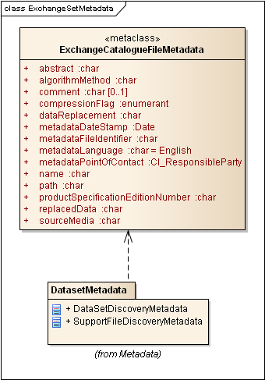

Figure 5 Exchange Set Metadata

### Exchange Catalogue File Metadata

All ICE Catalogue metadata files must contain at least the following metadata elements.

|  |  |  |  |  |
| --- | --- | --- | --- | --- |
| **Name** | **Cardinality** | **Value** | **Type** | **Remarks** |
| metadataFileIdentifier | 1 |  | CharacterString |  |
| metadataPointOfContact | 1 |  | CI_ResponsibleParty |  |
| metadataDateStamp | 1 |  | Date |  |
| metadataLanguage | 1 | English | CharacterString | All data sets conforming to this PS must use English language. The catalogue file must be in English. |
| name | 1 | CATALOG.ICE | CharacterString | Catalogue filename |
| abstract | 1 | CharacterString |  | Description of what the exchange catalogue contains |
| productSpecification | 1 | e.g. 1.0.0 |  | Product specification Version Number |
| comment | 0..1 | CharacterString |  | Any additional Information |

# Portrayal

To be done.